Inverted F Antenna Specification Summary
ITEM | ANT SPEC
Model Name | 2.4G ANT
Center  Frequency | Horizontal |  |  | Vertical
Center  Frequency | 2400MHz | 2400MHz | 2500MHz | 2400MHz | 2400MHz | 2500MHz
Center  Frequency | -1.26 | -0.76 | -0.58 | -5.25 | -2.46 | -1.86
MAX. Gain | -0.58dB
Polarization | Horizontal and Vertical
Azimuth Beam Pattern | Omni-directional
Impedance | 50 Ohm
Antenna Length | 38.20mm
Manufacture | SHENZHEN BATWIRELESS TECHNOLOGY CO.,LTD
Antenna Photo & Length (mm)
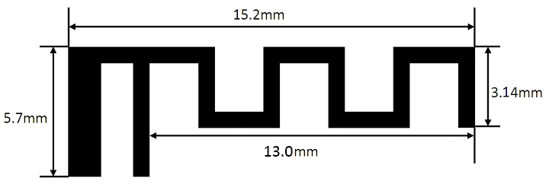

Horizontal: 2400 MHz 2450 MHz 2500 MHz
Power (dBm)
Max: 0 Min: -40 Scale: 5/div
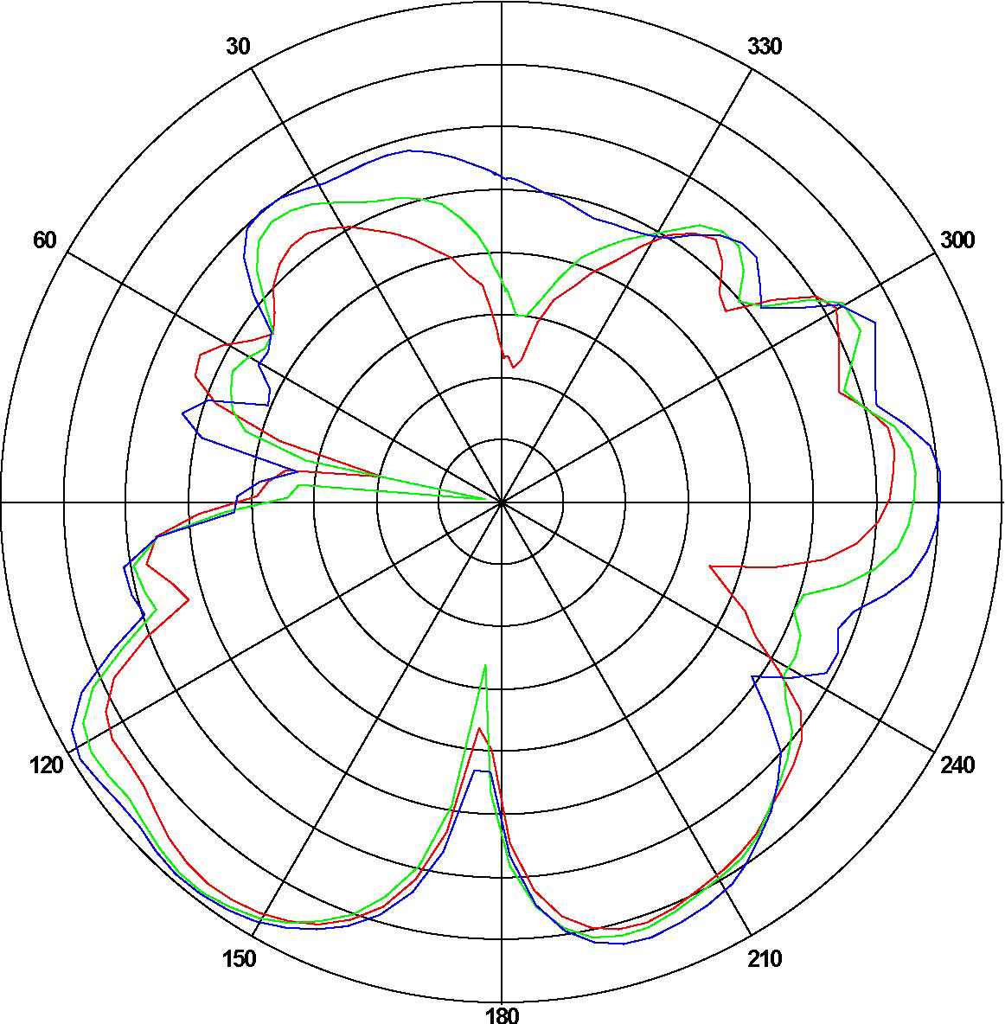
Frequency  (MHz) | Gain(dB)
Frequency  (MHz) | Max | Min | Avg
2400 | -1.26174 | -30.0801 | -7.18716
2450 | -0.765802 | -36.5604 | -7.48023
2500 | -0.585582 | -22.0315 | -6.59127

Vertical: 2400 MHz 2450 MHz 2500 MHz
Power (dBm)
Max: 0 Min: -30 Scale: 5/div
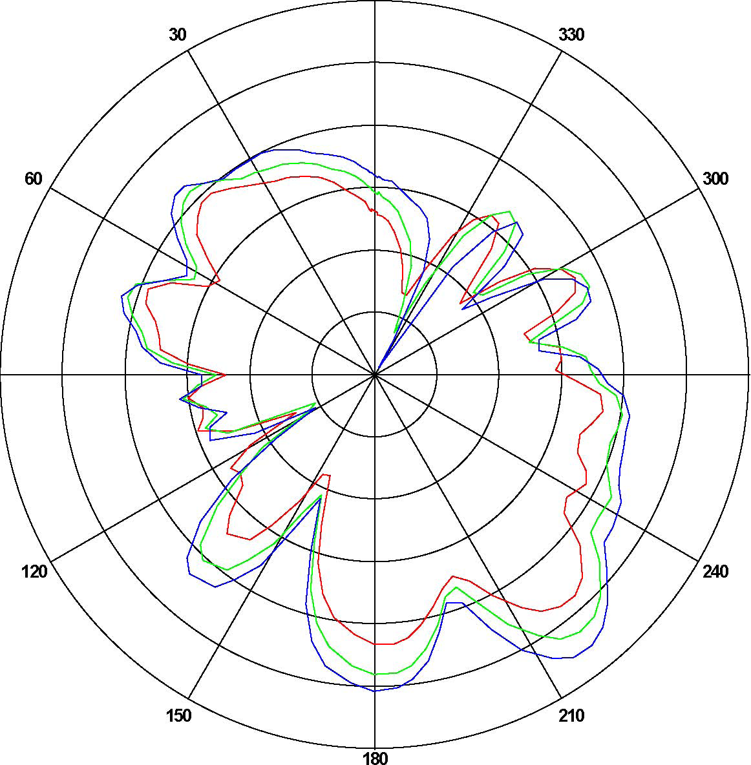
Frequency  (MHz) | Gain(dB)
Frequency  (MHz) | Max | Min | Avg
2400 | -5.2537 | -22.1424 | -12.4294
2450 | -2.4652 | -24.5837 | -10.4702
2500 | -1.86120 | -29.5214 | -9.20432
ANT Test Labs：Attestation of Global Compliance Co., Ltd.

